Year 9 Work for the 13th January
Subject | Work Set
English | Research the social system of Britain in the 1920’s (250 words)
Maths | Revision for test. Chapter 5 and 6.  My review and my practice.  Assessment will still take place as scheduled – Thursday 17th January
Biology | Using your textbook, review the Animal Nutrition Topic, pages 73-78 and make additional notes from these pages. Ensure your notes answer the following questions  - Explain the different energy needs for different groups of people; e.g. the elderly, young, babies etc.  - Explain how our bodies use vitamin C, D and minerals Calcium and iron. This must include deficiencies  - Produce a leaflet on fat/heart disease, obesity and starvation and malnutrition. Please include information on kwashiorkor and Marasmus
Chemistry | 1. Read pages 302-303, list the 2 chemical tests for the presence of water  2. Read pages 11- 13 and state uses of water in:  - Industry  - Home  3. Read pages 11-13 and explain in outline, the treatment of water supply in terms of filtration and chlorination. Watch the video on the following link: https://www.youtube.com/watch?v=tuYB8nMFxQA  4. Read pages 11-13 and list the implications of an inadequate supply of water, limited to safe drinking water and water for crop irrigation. Find an interesting Youtube video to share with the class at the next lesson.
Physics | On a new sheet of lined A4 paper, write the date and today’s lesson number and title. Complete all of the following work on your note paper:  - Read Topic 6.4 Energy Calculations on pp. 87 – 90. Answer questions 6.15 to 6.21 on p. 90. Then:  - Calculate the p.e. of a 7.5 kg mass when it is:  - 5 meters above the ground.  - 8 meters above the ground.  - Show all your working and state the formula that you use.  3. Calculate the k.e. of the following bodies in motion:  - A 1.5 kg toy truck, travelling at 2.5 m/s.  - A 1.8 g bullet travelling at 420 m/s.  - A 825 kg car, travelling at 84 km/h.  - What is the speed of an object of mass 2.5 kg that has 200 J of ke?  4. A 100 g steel ball falls from a height of 1.8 m onto a metal plate and rebounds to a height of 1.25 m. Find:  - The p.e. of the ball before it falls  - Its k.e. just as it hits the metal plate  - Its speed just as it hits the plate  - Its k.e. just as it leaves the plate on the rebound  - Its speed of rebound
French | Page 20 and 21, all reading exercises 1, 2, and 3. Then, write a paragraph to talk about what you and your friends like to do and don’t like to do in your free time. Include some examples of the past tense to say what you and your friends did at the weekend.
Business | If you have your textbook at home then go to page 65, 66 and 67. Read about F.W Taylor and Herzberg’s motivational theories. Make some notes about the key features of their theories. If you do not have your textbook you can use the Internet to research their theories.
Spanish | Use page 28 to compile a list of all school subjects, then revise opinion phrases (page 6) in addition read the green Opinion verbs box on page 28. Go to Ex 2 page 28 read the opinion phrases and translate into English. Finally write 10 opinion phrases about your school subject likes and dislikes (use adjectives to give reasons)
Art | 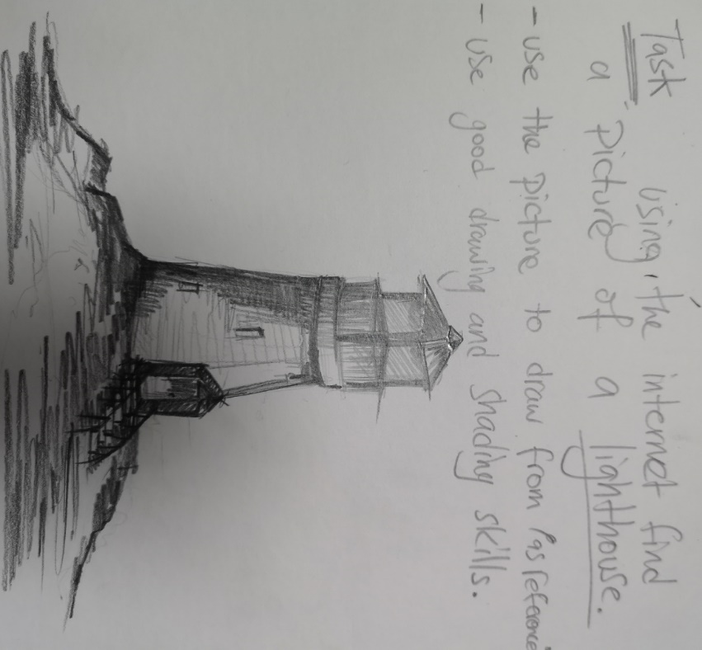  Using the internet find a picture of a lighthouse. Use the picture to draw as referenced below. Use good drawing and shading skills.
Geography | Students should go the classroom website www.mrsralphsclassroom.com continue to take notes from the slides on the below topics for the next lesson. Complete all tasks and questions on the slides.  Year 9: Plate Tectonics
Computer Sci | Revise for topic test next week (ethics / security chapters).
Arabic and Islamic | Arabic 1  Read the story that you have written and write a summary.  Arabic 2- Beginners  Practice new vocabulary for the spelling test.  Arabic 2- Advanced  Finish the Project you started in the lesson.
History | Research and create a detailed mind maps on the Wall Street Crash and the Great Depression
Psychology | - Complete Stroop task  - Ensure Condition A and B are filled in  - Work out averages for each condition  - Complete page 1 (Hypotheses)
ICT | Revise for topic test next week (networks / effects of ICT)
PE | Students are to complete the set of 12 exercises. They can complete the exercises in any order but they have to complete the correct timings and amounts.  Students should time themselves to see how quickly they can complete the circuit. Students are to then bring their times to the PE department to receive house points. The fastest female/male to bring their timings in to the PE department will receive a reward.  15 burpees  50 squats  45 second plank  100 star jumps  50 sit ups  1 minute wall squat  40 push ups  36 lunges (18 on each leg)  30 second high knees  1 minute skipping  50 side leg lifts (25 on each leg)  15 jump squats

