Year 8 Work for the 13th January
Subject | Work Set
English | Research the social and historical context of the novella ‘Of Mice and Men’ (250 words)
Maths | Revision for test. Chapter 5 and 6.  My review and my practice.  Year 8 assessment due today will take place tomorrow Monday 14th January
Biology | Students to read through pages 50 and 51 from the textbook, 12.1 micro-organisms. You are to produce a leaflet for Tawam Hospital, explaining the differences between fungi, bacteria and viruses. Success criteria includes a labelled diagram and examples.
Music (8A and 8C) | Research the life of at least 3 Film Composers. Include a list of their films, awards and interesting facts about their careers.  Put the information into bullet points. You can do this on a power point presentation including any clips from their most successful films if you wish.  If you do not have your books then complete this work onto paper transferring it onto your books when you return to school.
Arabic and Islamic | Arabic 1  Read the story that you have written and write a summary  Arabic 2- Beginners  Practice new vocabulary for the spelling test.  Arabic 2- Advanced  Finish the Project you started in the lesson.
Art | Now that you know about 3D shapes, use what you have learnt to draw your TV remote control. Use 1,2- or 3-point perspective. Use elements of line, shape, tone and texture together with 3-dimensional form. Extra marks will be awarded for 2,3-point perspective.  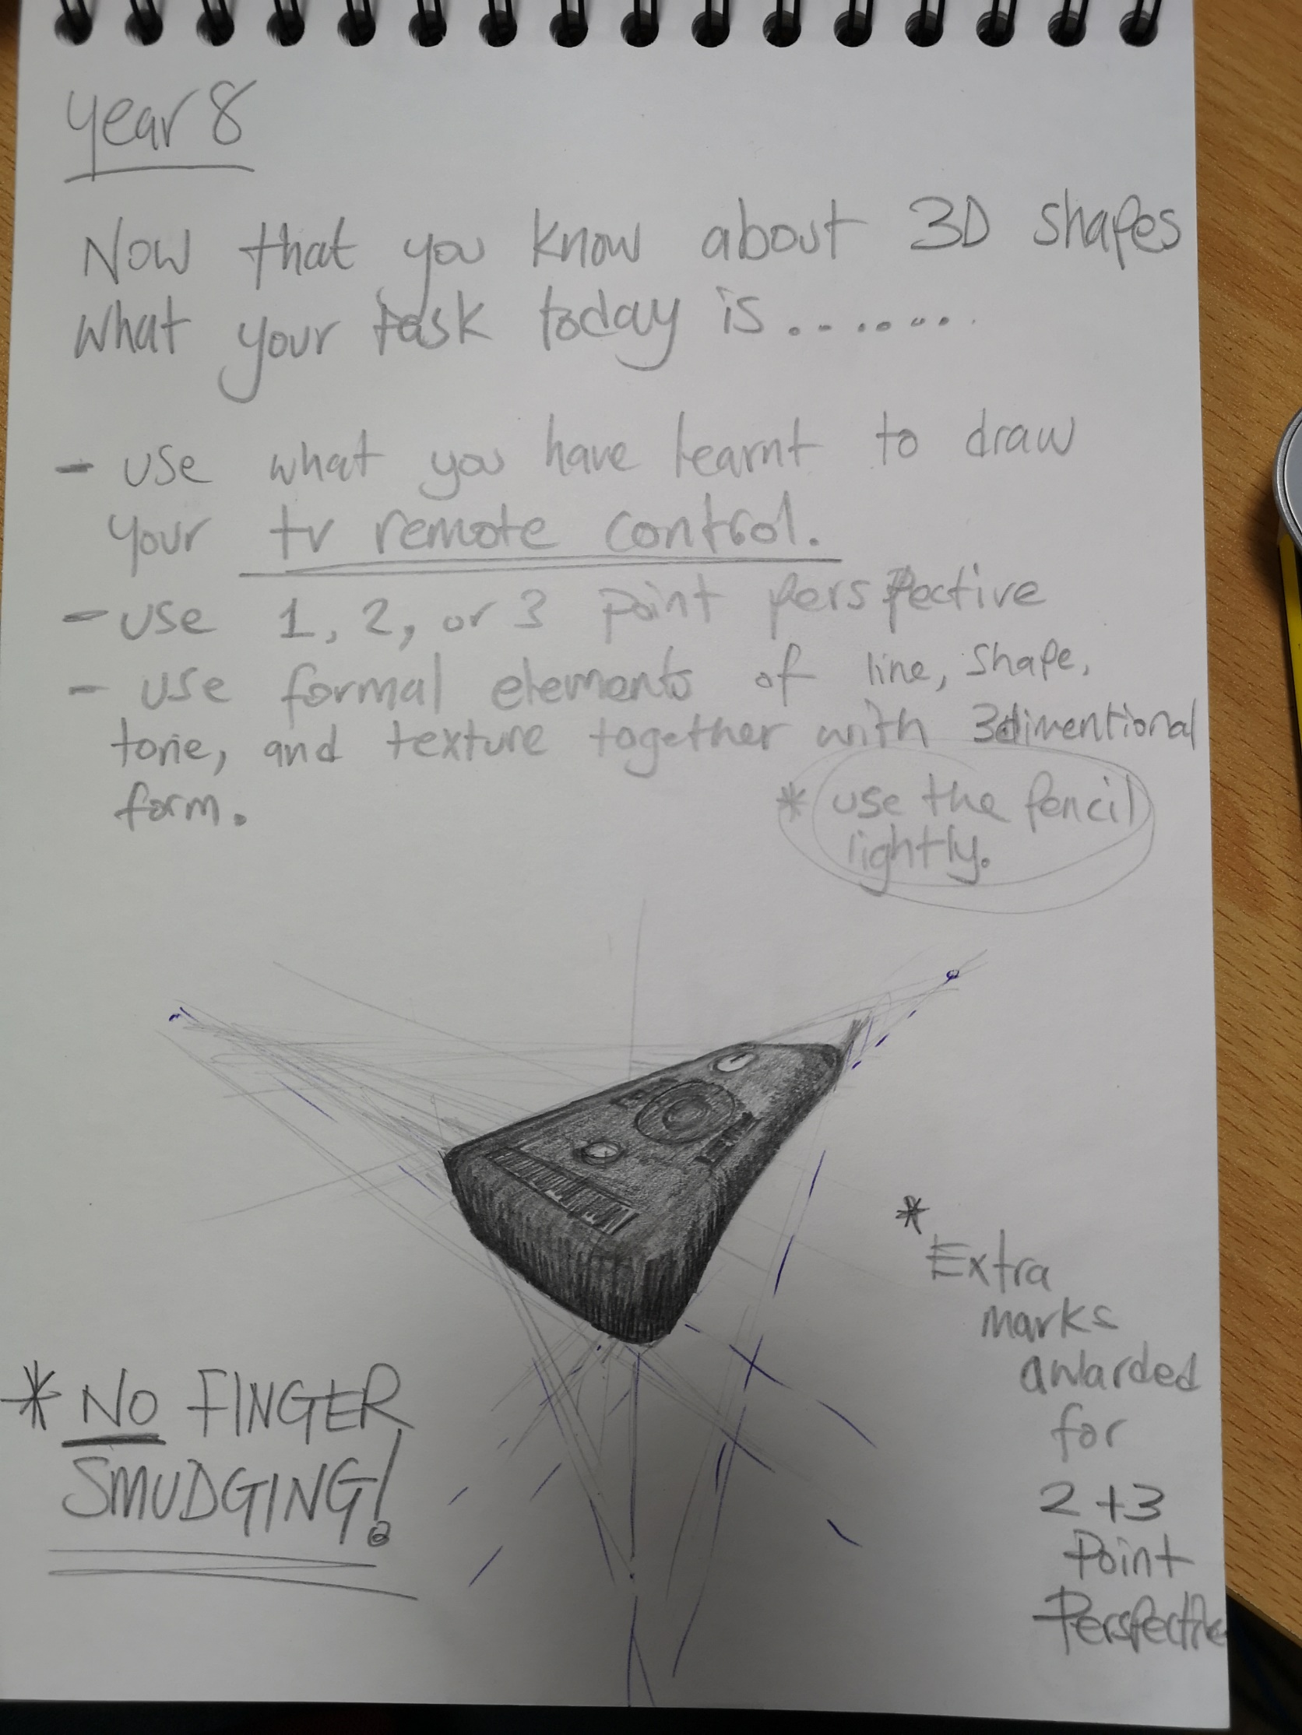
History | All groups - revise for end of unit test on the Native American Indians
Geography | Students should go the classroom website www.mrsralphsclassroom.com continue to take notes from the slides on the below topics for the next lesson. Complete all tasks and questions on the slides.  Year 8: weather and climate
Psychology | - Complete Stroop task  - Ensure Condition A and B are filled in  - Work out averages for each condition  - Complete page 1 (Hypotheses)
ICT | Revise for topic test next week (flow charts and algorithms).
PE | Students are to complete the set of 12 exercises. They can complete the exercises in any order but they have to complete the correct timings and amounts.  Students should time themselves to see how quickly they can complete the circuit. Students are to then bring their times to the PE department to receive house points. The fastest female/male to bring their timings in to the PE department will receive a reward.  15 burpees  50 squats  45 second plank  100 star jumps  50 sit ups  1 minute wall squat  40 push ups  36 lunges (18 on each leg)  30 second high knees  1 minute skipping  50 side leg lifts (25 on each leg)  15 jump squats

