Year 7 Work for the 13th January
Subject | Work Set
English | Write a diary account (from Michael’s perspective) for your unexpected day off school (200 words)
Maths | Revision for test. Chapter 5 and 6.  My review and my practice.  Assessment will still take place as scheduled – Tuesday 15th January
Science | Use this day to ensure that you prepare well for your Science Test tomorrow. Use pages;  26-31  54-57  Review the experiment to show that plants produce oxygen, page 59.
Geography | Students should go the classroom website www.mrsralphsclassroom.com continue to take notes from the slides on the below topics for the next lesson. Complete all tasks and questions on the slides.  Year 7: Urbanisation
History | All groups - revise and research Hannibal and the Punic Wars in preparation for in class written assessment
Arabic | Arabic 1  Read the story that you have written and write a summary  Arabic 2- Beginners  Practice new vocabulary for the spelling test.  Arabic 2- Advanced  Finish the Project you started in the lesson.
Art | Draw a glass: use the formal elements; line, shape texture and tone to create a realistic drawing of a glass. Remember to press lightly with your pencil and use all levels of tone.  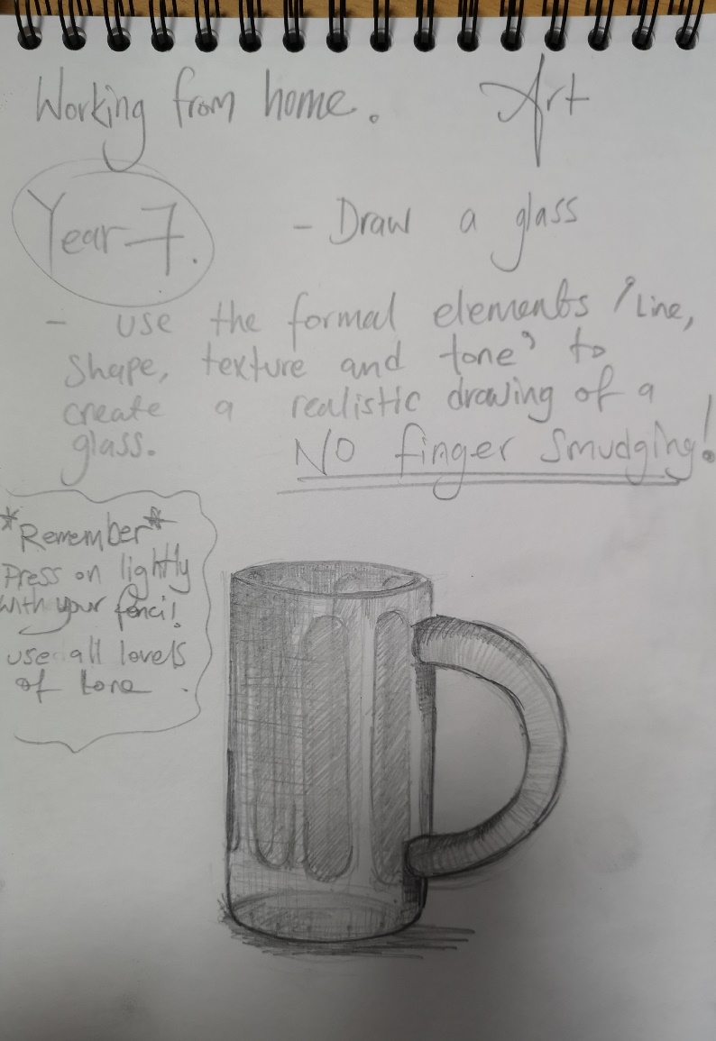
ICT | Revise for topic test next week.
PE | Students are to complete the set of 12 exercises. They can complete the exercises in any order but they have to complete the correct timings and amounts.  Students should time themselves to see how quickly they can complete the circuit. Students are to then bring their times to the PE department to receive house points. The fastest female/male to bring their timings in to the PE department will receive a reward.  15 burpees  50 squats  45 second plank  100 star jumps  50 sit ups  1 minute wall squat  40 push ups  36 lunges (18 on each leg)  30 second high knees  1 minute skipping  50 side leg lifts (25 on each leg)  15 jump squats

