Topics of Study  - Introducing yourself by name  - Saying your age  - Saying when your birthday is  - Saying what you have in your bag  - Talking about the classroom  - Saying what colour things are  - Talking about where you live  - Talking about family members  - Talking about animals  - Hair and eye colour  - Saying what subjects you study  - Telling the time  - Talking about your school day  - Talking about what you wear  - Talking about sports  - Saying what you do in your freetime and at the weekend | Should you require any further information please don’t hesitate to contact the MFL Department at AAESS | Head of Spanish : Mrs. B Rodwell  brodwell@aaess.sch.ae  Head of French : Mr. M Parry  mparry@aaess.sch.ae | Year 7 French @ AAESS  - Here you will find all the information you need in order to help you make decisions regarding why to choose French for your language option.  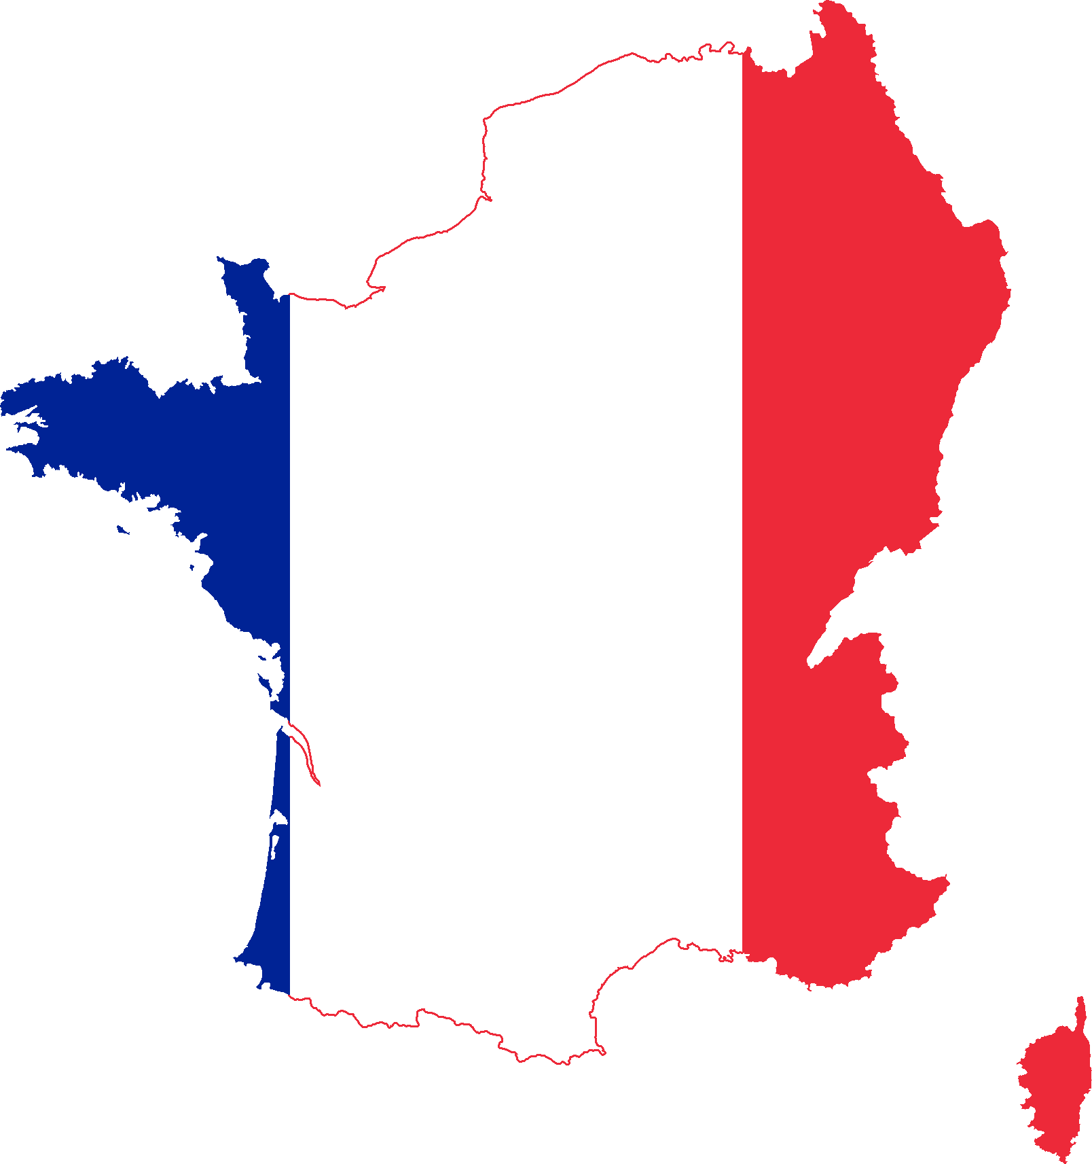  
Term 1 Assessment  You will complete 4 assessments in November at the end of Unit 1  Paper 1 Listening  Understanding and responding to different types of spoken language  Paper 2 Reading  Understanding and responding to different types of written language.  Paper 3 Writing  Communicating effectively in writing for a variety of purposes.  Paper 2 Speaking  Communicating and interacting effectively in speech for a variety of purposes. | Term 2 Assessment  You will complete 2 Assessments in February at the end of Unit 2  Paper 1 Writing  Communicating effectively in writing for a variety of purposes.  Paper 2 Speaking  Communicating and interacting effectively in speech for a variety of purposes. |  | Term 3 Assessment  You will complete End of Year Assessments in May these assessments will form the basis of your end of Year report grade.  Paper 1 Listening  Understanding and responding to different types of spoken language  Paper 2 Reading  Understanding and responding to different types of written language.  Paper 3 Writing  Communicating effectively in writing for a variety of purposes.

